**Groove Welds**

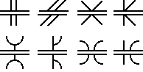

The **groove weld** is commonly used to make edge-to-edge joints, although it is also often used in corner joints, T joints, and joints between curved and flat pieces. As suggested by the variety of groove weld symbols, there are many ways to make a groove weld, the differences depending primarily on the geometry of the parts to be joined and the preparation of their edges. Weld metal is deposited within the groove and penetrates and fuses with the base metal to form the joint. (Note: for the sake of graphical clarity, the drawings below generally do not show the penetration of the weld metal. Recognize, however, that the degree of penetration is important in determining the quality of the weld.)

The various types of groove weld are:

The **square** groove weld, in which the "groove" is created by either a tight fit or a slight separation of the edges. The amount of separation, if any, is given on the weld symbol.

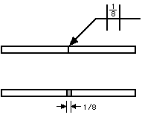

The **V-groove** weld, in which the edges of both pieces are chamfered, either singly or doubly, to create the groove. The angle of the V is given on the weld symbol, as is the separation at the root (if any).

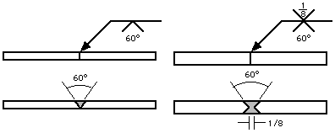

If the depth of the V is not the full thickness--or half the thickness in the case of a double V--the depth is given to the left of the weld symbol.

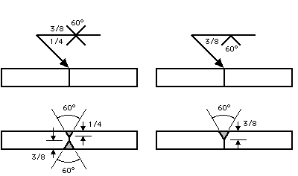

If the penetration of the weld is to be greater than the depth of the groove, the depth of the **effective throat** is given in parentheses after the depth of the V.

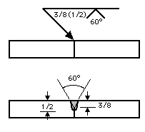

The **bevel** groove weld, in which the edge of one of the pieces is chamfered and the other is left square. The bevel symbol's perpendicular line is always drawn on the left side, regardless of the orientation of the weld itself. The arrow points toward the piece that is to be chamfered. This extra significance is emphasized by a break in the arrow line. (The break is not necessary if the designer has no preference as to which piece gets the edge treatment or if the piece to receive the treatment should be obvious to a qualified welder.) Angle and depth of edge treatment, effective throat, and separation at the root are described using the methods discussed in the [V-groove](http://www.unified-eng.com/scitech/weld/groove.html#vgroove) section.

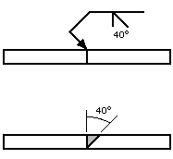

The **U-groove** weld, in which the edges of both pieces are given a concave treatment. Depth of edge treatment, effective throat, and separation at the root are described using the methods discussed in the [V-groove](http://www.unified-eng.com/scitech/weld/groove.html#vgroove) section.

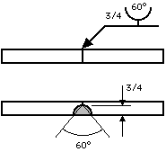

The **J-groove** weld, in which the edge of one of the pieces is given a concave treatment and the other is left square. It is to the U-groove weld what the bevel groove weld is to the V-groove weld. As with the bevel, the perpendicular line is always drawn on the left side and the arrow (with a break, if necessary) points to the piece that receives the edge treatment. Depth of edge treatment, effective throat, and separation at the root are described using the methods discussed in the [V-groove](http://www.unified-eng.com/scitech/weld/groove.html#vgroove) section.

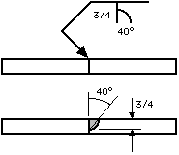

The **flare-V** groove weld, commonly used to join two round or curved parts. The intended depth of the weld itself are given to the left of the symbol, with the weld depth shown in parentheses.

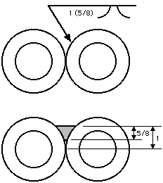

The **flare bevel** groove weld, commonly used to join a round or curved piece to a flat piece. As with the flare-V, the depth of the groove formed by the two curved surfaces and the intended depth of the weld itself are given to the left of the symbol, with the weld depth shown in parentheses. The symbol's perpendicular line is always drawn on the left side, regardless of the orientation of the weld itself.

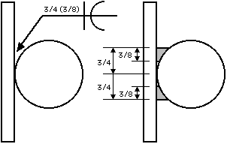

Common supplementary symbols used with groove welds are the **melt-thru** and **backing bar** symbols. Both symbols indicate that complete joint penetration is to be made with a single-sided groove weld. In the case of melt-thru, the root is to be reinforced with weld metal on the back side of the joint. The height of the reinforcement, if critical, is indicated to the left of the melt-thru symbol, which is placed across the reference line from the basic weld symbol.

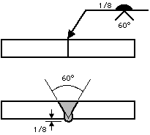

When a backing bar is used to achieve complete joint penetration, its symbol is placed across the reference line from the basic weld symbol. If the bar is to be removed after the weld is complete, an "R" is placed within the backing bar symbol. The backing bar symbol has the same shape as the plug or slot weld symbol, but context should always make the symbol's intention clear.

